
Tertiary Infotech Academy Pte Ltd
UEN: 201200696W
WRITTEN ASSESSMENT (SAQ)
For
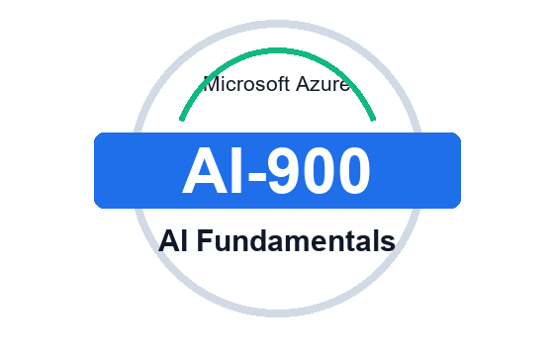
Microsoft Azure AI Fundamentals (AI-900)
TGS Ref No: TGS-2023021100
Conducted by
Tertiary Infotech Academy Pte Ltd
UEN: 201200696W
Version v1

Written Assessment (Short Answer Questions)
Microsoft Azure AI Fundamentals (AI-900) - TGS-2023021100 - v1

A. Trainee Information
Trainee Name
Last 3 NRIC Digits + Alphabet
Assessment Date
Assessor Name

B. Instructions to Candidate
- Answer all 12 open-ended questions.
- This assessment tests knowledge covered in the course slides and labs.
- Use approved course materials only as instructed by the assessor.
- Write clear, concise answers in the space provided.

C. Questions
Question 1 (K1)
A retailer wants to use AI for image checking, customer feedback analysis, invoice extraction, product recommendations and campaign copy. Explain how you would identify the AI workload type for each requirement.
Alignment: Slides 16, 24, 26; Lab 01

Question 2 (K2)
Describe the responsible AI principles that should be considered before deploying an Azure AI solution.
Alignment: Slides 28, 72; Lab 01

Question 3 (K3)
Differentiate regression, classification and clustering using one workplace example for each.
Alignment: Slides 29, 35-38; Lab 02

Question 4 (K4)
Explain the main stages in a machine learning lifecycle and how Azure Machine Learning supports them.
Alignment: Slides 29, 39-42; Lab 03

Question 5 (K5)
A business asks for image analysis, text sentiment analysis, speech transcription and document extraction. Map each requirement to the closest Azure AI service.
Alignment: Slides 27, 43-58; Labs 04-07

Question 6 (K6)
What should a learner check when validating output from a computer vision or OCR activity?
Alignment: Slides 43-46; Lab 04

Question 7 (K7)
Explain common natural language processing outputs and how they can support a business decision.
Alignment: Slides 47-50; Lab 05

Question 8 (K8)
Compare speech recognition, speech synthesis and translation in an Azure AI scenario.
Alignment: Slides 51-54; Lab 06

Question 9 (K9)
Explain how document intelligence and knowledge mining are different but related.
Alignment: Slides 55-58; Lab 07

Question 10 (K10)
Describe the main controls needed when using generative AI, Azure AI Foundry or Azure OpenAI.
Alignment: Slides 30, 59-62; Lab 08

Question 11 (K11)
List governance, privacy, security, cost and cleanup controls that should be included in an Azure AI solution design.
Alignment: Slides 63-66, 72; Lab 09

Question 12 (K12)
Given a new AI business scenario, what steps should you follow to recommend an Azure AI service and prepare for assessment review?
Alignment: Slides 67-74; Lab 10

For Official Use Only
Assessment Result | Competent / Not Yet Competent
Assessor Name
Assessor NRIC
Date
Signature

